|  |
| --- |
|  |
| All in 1 Windsor |
| Project Report |

|  |
| --- |
| Group 10  12-4-2015 |



**Abstract**

This report is an “Elaboration phase II” document. Here, the whole requirements of the software are programmed and tested, the majority of requirements are discovered and stabilized and the major risks are mitigated or retired.

This software is an android application which can be helpful in locating places like restaurants, malls, hospitals and worship places etc. This application is precisely engineered with respect of business case of “International students” arriving at Windsor city.

This multicultural App will be helpful in locating the maps and selecting a location which will show the distance from current location to destination and the different ways to choose the transport. It will also show bus routes wherever applicable.

**Table of Contents**

1. **Introduction**

1.1 Scope

1.2 Technologies to be used

1.2.1 Hardware Interfaces

1.2.2 Software Interfaces

1.2.3 Memory Constraints

1.3 Dependencies

**2. The Overall Description**

2.1 Use Case Diagrams

**3. Project Planning**

3.1 Software Process Model

3.2 Project Plan

3.3 Project Scheduling & Code Repository

3.4 Risk Identification

**4. Implementation**

**5. Testing**

5.1 Black-box testing

5.2 White-box testing

**6. Future Enhancements**

**7. Conclusion**

1. **Introduction**

This software is an android application which can be helpful in locating places like restaurants, malls, hospitals and worship places etc. This application is precisely engineered with respect of business case of “International students” arriving at Windsor city.

This multicultural App will be helpful in locating the maps and selecting a location which will show the distance from current location to destination and the different ways to choose the transport. It will also show bus routes wherever applicable.

* 1. **Scope**

This android application allows user to get information about nearby restaurants, police stations, parks, shopping malls, etc. The business scope of the project is to target new students coming to Windsor, Canada for the first time. The main aim of the project is to make most services we can, available on the finger tips of the user.

* 1. **Technologies to be used**
     1. **Softwares Interfaces**

Application Development Tools: Eclipse Mars (with ADT Plugin)

SDK: Android SDK

Languages:

Coding: Java

Deigning: XML

AVD: Genymotion (Free for personal use)

External Interface: Google Maps

Android version: API 18 (Jelly Bean) to API 22 (Lollipop)

* + 1. **Hardware Interfaces**

Processor: ARM v7 Processor or above, 1GHz Minimum

RAM: Minimum 256 MB

HDD: 60 MB free space

GPS: GPS sensor

* + 1. **Memory Constraints**

User should have at least 100 mb free space for the application to run smoothly and to install successfully minimum 50 mb free space is required.

* 1. **Dependencies**

The software is dependent on Google Maps application and GPS sensor in order to show full map functionalities.

1. **Plot of Plan**

**2.1 Use Case Diagrams**

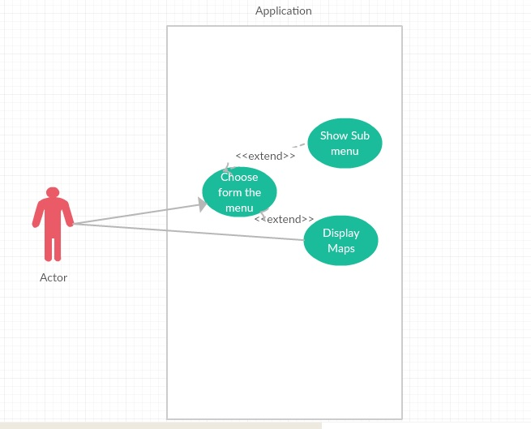Here the Use case diagram can be seen where the Actor selects an option and it leads either to the sub menu or maps (extending the menu).

Fig 1. Actor interacts with Application which has different use cases.

1. **Project Planning**
   1. **Software Process Model**

Agile Software Development is a set of [software development methods](https://en.wikipedia.org/wiki/Software_development_methodologies) in which requirements and solutions evolve through collaboration between self-organizing, [cross-functional teams](https://en.wikipedia.org/wiki/Cross-functional_team). It promotes adaptive planning, evolutionary development, early delivery, continuous improvement, and encourages rapid and flexible response to change. [Source: Wikipedia]

To solve actual problems in an industry setting, software engineer or a team of engineers must incorporate a development strategy that encompasses the processes, methods, tool layers and generic phases. This strategy is often referred to as process model or a software engineering paradigm. A process model for software engineering is chosen based on the nature of the project and application, the methods and tools to be used.

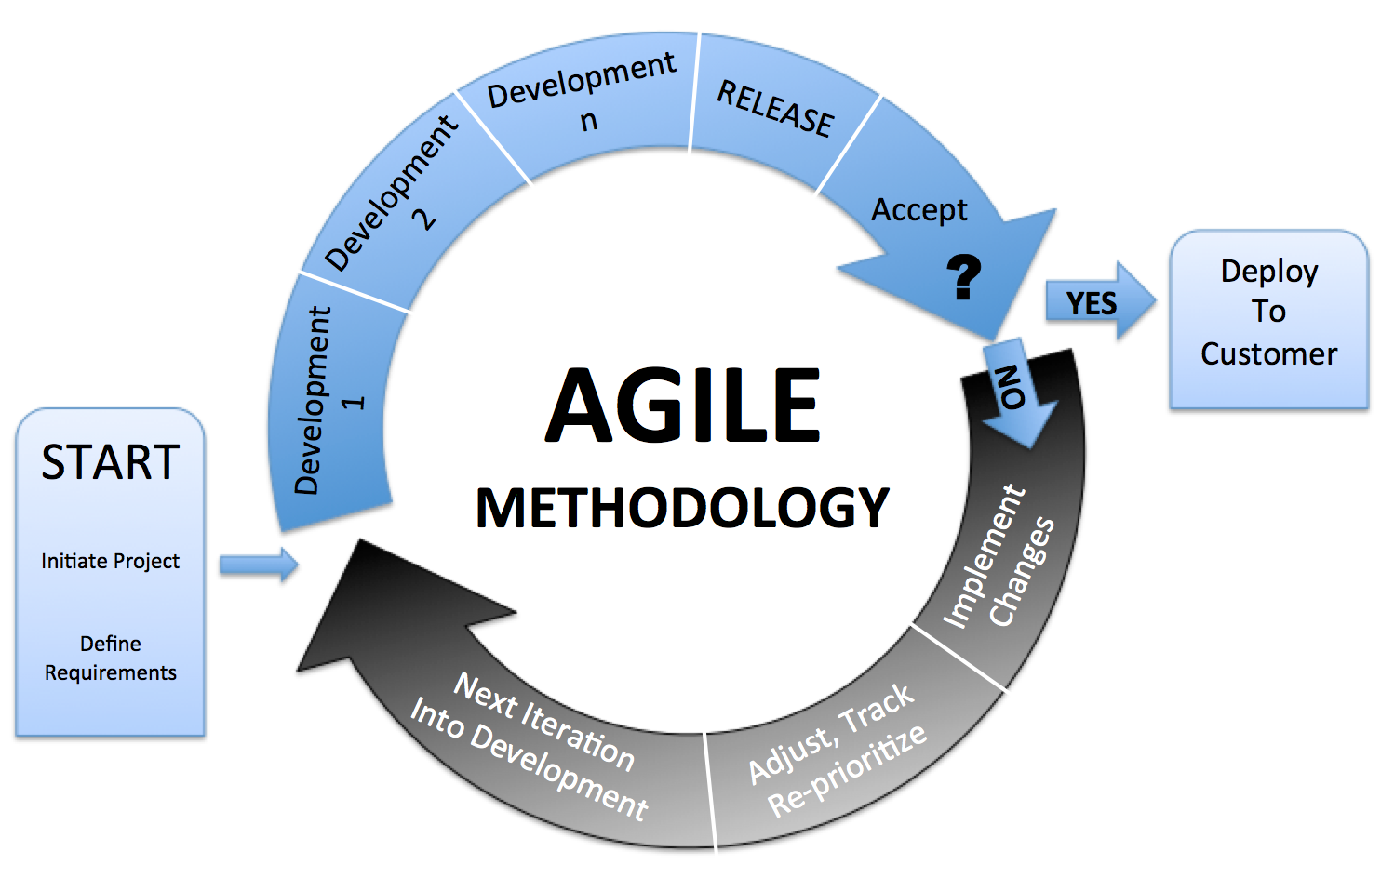

Fig 2. Agile methodology

[Source: http://www.code4nord.com/wp-content/uploads/2015/09/Agile.png]

* 1. **Project Plan**

In the development of this project, it was first checked if the project is feasible functionally, technically and economically. Then the requirements from the end users were collected and then analyzed.

* 1. **Project Scheduling & Code Repository**

We have made use of red mine for keeping track of the issues and distribution of tasks. It can be accessed via link: <https://redmine.cs.uwindsor.ca>

Code Repository: <https://github.com/DhawalRank/MultiCulturalApp>

Fig 3. Red mine Screenshot.

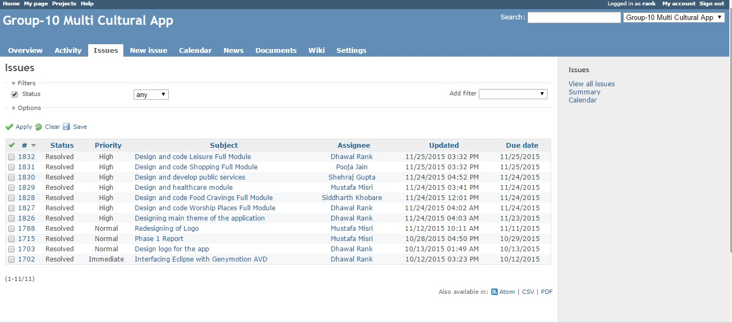

* 1. **Risk Identification**

Risk Identification is a systematic and procedural attempt to specify threats to the project plan. These threats can be of many types as listed below.

There are two types of risks: Generic and Product Specific.

One method for identifying risks is to create a risk item checklist. The checklist can be used for identification and focused on some subset of known and predictable risks in the following generic subcategories:

Product Size

Risks associated with the overall size of software to be built or modified. In this case it is the risk associated with the defined web application to be built.

Business Impact

Risks associated with constraints imposed by management or the marke place. But the application being developed as the final year project, the marketplace constraints are not too strict.

Process Definition

The risk of getting out of the line of definition. In other words, risks associated with the degree to which the software process has been defined and is followed by the development organization.

Development Environment

Risks associated with the availability and quality of tools to be used to build the product. But all the quality tools and genuine software applications are provided so this risk is indeed eliminated.

1. **Implementation**

**Home Page:**

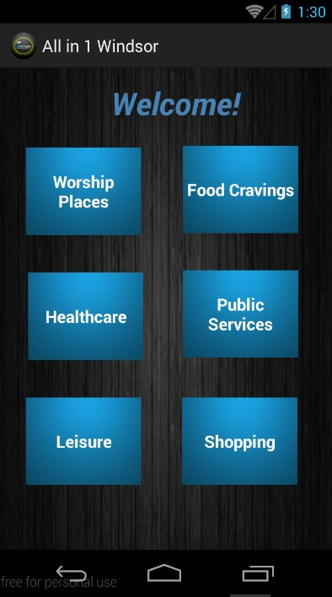

**Leisure:**

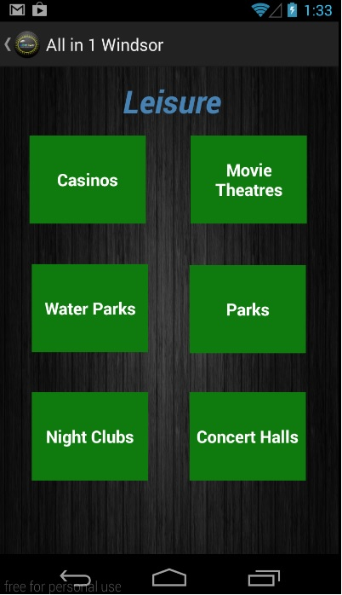

**Directed to Google Maps on clicking Night Clubs in Leisure Page:**

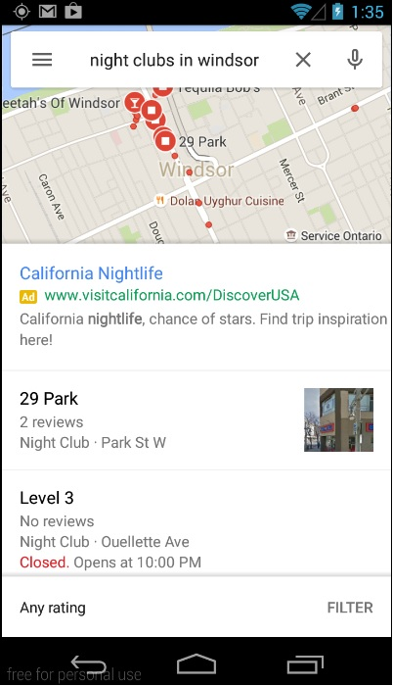

1. **Testing**
   1. **Black-box Testing**

In Black-Box Testing or Functional Testing, developers are concern about the output of the module and the application, i.e. whether the application gives proper output as per the requirements or not. In another words, this testing aims to test a program's behavior against its specifications without making any reference to the internal structure of the program or the algorithms used. Therefore, the source code is not needed, and so even purchased modules can be tested. The program just gets a certain input and its functionality is examined by observing the output. This can be done in the following way:

* Input Interface
* Processing
* Output Interface

The tested program gets certain inputs. Then the program does its job and generates a certain output, which is collected by a second interface. This result is then compared to the expected output, which has been determined before the test.

* 1. **White-Box Testing**

White Box testing is used as an important primary testing approach. Here code is inspected to see what it performs; tests are designed to exercise the code. Code is tested using code scripts, driver, etc. which are employed to directly interface with and drive the code. The tester can analyze the code and use the knowledge about the structure of a component to derive the test data.

We have implemented following two test methods for our application.

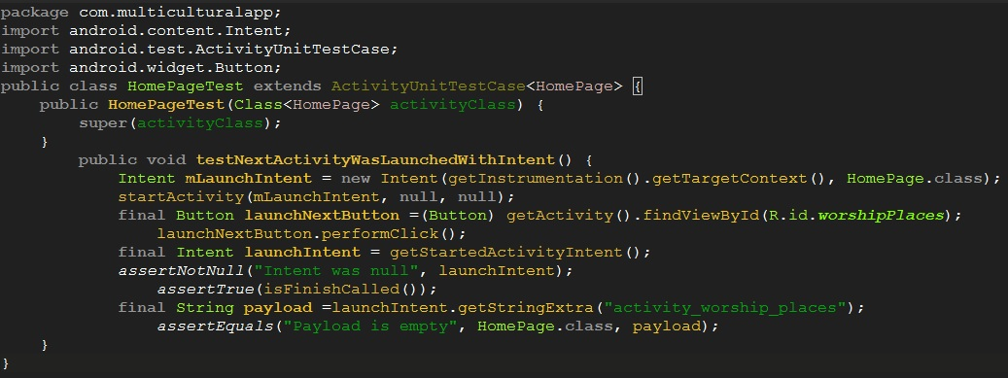

Here in the code “assertTrue ()” will make sure that the intent opened on button click was not null and the other method “assertEquals ()” will make sure that the open intent was the desired intent or not.

1. **Future Enhancements**

In future iterations we can include features like live news feeds from local news paper agencies so that we can keep our users updated with the local news. As we know that Canada experiences harsh weather, we are also planning to provide weather updates in our application. Moreover, we plan to provide the CIC updates in our application. In short, we want to provide as much information as we can in a single platform so that our user has no need to go on google searching everything.

1. **Conclusion**

We value Canadian diversity and we have tried our best to meet all the non-functional requirements. The application already meets most of the requirements stated but a software is never complete. There are always chances of new additions to the software. And as we are using agile methodology, changes are always welcomed.